**Project Design Phase-II Technology Stack (Architecture & Stack)**

|  |  |
| --- | --- |
| Date | 03 October 2022 |
| Team ID | **PNT2022TMID12665** |
| Project Name | Project – IOT Based Safety Gadget for Child Safety Monitoring and Notification |
| Maximum Marks | 4 Marks |

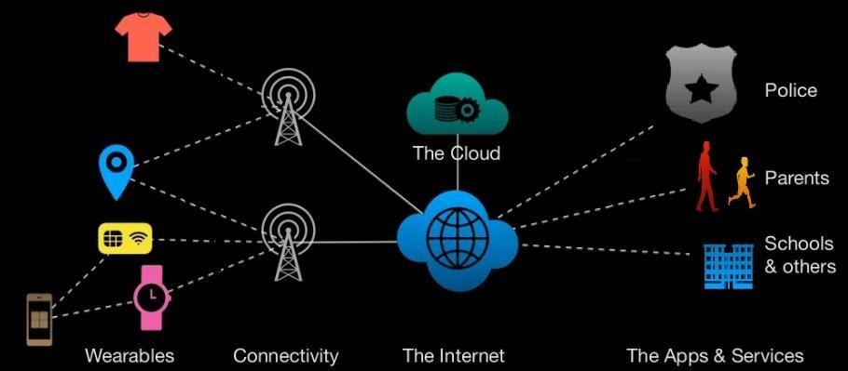

Table-1 : Components & Technologies:

|  |  |  |  |
| --- | --- | --- | --- |
|  | **Component** | **Description** | **Technology** |
|  | User Interface | Web UI, Mobile App. | HTML, CSS, JavaScript |
|  | Application Logic-1 | Code Development Phase | Python |
|  | Application Logic-2 | Interfacing purposes | IBM Watson Assistant |
|  | Browser-based flow editor | Visual Programming | Node Red |
|  | Cloud Database | Database Service on Cloud | IBM Cloud |
|  | File Storage | Usage of IBM Cloud Storage | IBM Block Storage |
|  | Infrastructure (Server / Cloud) | Application Deployment on Local Server | Cloud Platform |

Table-2: Application Characteristics:

|  |  |  |  |
| --- | --- | --- | --- |
|  | **Characteristics** | **Description** | **Technology** |
|  | Open-Source Frameworks | A template for software developmentthat is designed by a social network. | IBM Watson Platform, NodeRed. |

|  |  |  |  |
| --- | --- | --- | --- |
|  | **Characteristics** | **Description** | **Technology** |
|  | Security Implementations | Each and every parent should take care of their own children, without letting them to fall into the dark world of abuses, which entirely ruin them physically, mentally and emotionally destroying our future. Hence, considering the importance of ourfuture, our project makes it easy for parents to track their children and to visually monitor them on regular basis, which makes them ensure the safety of their children and reduces the rate of  incidents of child abuse. | Notifications and Alerts |
|  | Scalable Architecture | If any abnormal values are read by the sensor, then an SMS is sent to the parents mobile and an MMS indicating an image captured by the serial camera is also sent. The future scope of the work is to implement the IoT device  which ensures the complete solution for child safety problems. | Implementation usingSoftware. |
|  | Availability | The solution represented takes advantages of Open-source platforms. | NODE RED, IBM cloud,  IBM IoT platform. |

|  |  |  |  |
| --- | --- | --- | --- |
|  | Performance | GPS is useful for tracking child and also provides the information where the child is currently located as well as it also informs the parents how long his child is far away from his parents. SMS services used when smart phones do not support internet connectivity in this case child is able to send a text message or exact location in the parents. This system is going to help the parents to track the location of their children without informing them  because their movement is displayed on the parent’s phone. | GPS |